Article type: Research Article
Title: The Alpine Germination Syndrome differs between Temperate and Mediterranean habitats
Author list:
Espinosa del Alba, Clara^{1,2*}, Fernández-Pascual, Eduardo^{1,2}, Götzenberger, Lars^{3,4} & Jiménez-Alfaro, Borja^{1,2}.
ORCIDs
Clara Espinosa Del Alba. https://orcid.org/0000-0001-8634-5808
Eduardo Fernández-Pascual. https://orcid.org/0000-0002-4743-9577
Lars Götzenberger. https://orcid.org/0000-0003-3040-2900
Borja Jiménez-Alfaro. https://orcid.org/0000-0001-6601-9597
Affiliations
1. Biodiversity Research Institute (IMIB), University of Oviedo-CSIC-Principality of Asturias, 33600 Mieres, Spain.
2. Department of Organismal and Systems Biology, University of Oviedo, Oviedo, Asturias, 33071, Spain.
3. Czech Academy of Sciences, Institute of Botany, Czech Republic.
4. Department of Botany, Faculty of Sciences, University of South Bohemia, Ceske Budejovice, 37 005, Czech Republic
Correspondence author:
Clara Espinosa del Alba. Email: espinosaclara@uniovi.es
Funding sources
This work was supported by Agencia Estatal de Investigación (grant number: AEI/10.13039/501100011033); Ayuntamiento de Gijón/Xixón (grant number: SV-23-GIJON-JBA) and Grant “Laboratorio de Vegetación y Biodiversidad” (grant number: IDE/2024/000720, Principality of Asturias-Sekuens-EU-FEDER).
Acknowledgements
We want to thank the Picos de Europa National for support in field sampling. This research is framed within the SEEDALP project (MCI-20-PID2019-108636GA-I00) funded by the Agencia Estatal de Investigación (AEI/10.13039/501100011033), and supported by Ayudas para Contratos Predoctorales para la Formación de Doctores del Ministerio de Ciencia e Innovación (FPI: MCI-21-PRE2020-092874); Ayuntamiento de Gijón/Xixón - Jardín Botánico Atlántico (SV-23-GIJON-JBA) and the grant “Laboratorio de Vegetación y Biodiversidad” (IDE/2024/000720, Principality of Asturias-Sekuens-EU-FEDER). L.G. was supported by the long-term research development project number RVO67985939 of the Czech Academy of Sciences.
Author contributions CREDIT
Conceptualization: Borja Jiménez-Alfaro; Formal Analysis and investigation: Clara Espinosa del Alba, Eduardo Fernández-Pascual; Writing – original draft preparation: Clara Espinosa del Alba; Writing – Review & Editing: all authors; Supervision: Borja Jiménez-Alfaro, Eduardo Fernández-Pascual, Lars Götzenberger; Funding acquisition: Borja Jiménez-Alfaro.
Data availability statement
Raw data and R script for analysis are available in GitHub; once the manuscript is accepted, the GitHub repository will be public and stored in Zenodo. (add later in reference list)
Statements and Declarations
The authors have no relevant financial or non-financial interests to disclose.
Supporting Information
Appendix S1. Species individual germination responses to the different germination treatments studied.
Appendix S2. Raw germination data
Appendix S3. MCMC germination model results
Appendix S4. Species summary germination results per treatment

Abstract (max 300 words)
- Aims: Recently, alpine communities have shown changes in plant composition, potentially influenced by alterations in their reproductive performance. Therefore, understanding the environmental cues that stimulate germination is crucial for forecasting future impacts. The germination requirements of alpine plants are highly species-specific; however, literature has identified a general alpine germination syndrome. Nonetheless, germination responses to specific environmental cues between different regional alpine habitats have been rarely directly compared.
- Location: Cantabrian mountains (northwestern Spain).
- Methods: We examined four germination cues in 56 grassland species from Mediterranean and temperate alpine habitats. First, we subjected the seeds to five months of cold stratification, mimicking snow-like conditions, and recorded their germination. Subsequently, using the remaining non-germinated seeds, we tested the effects of water limitation, darkness, and constant temperatures on final germination compared to control conditions.
- Results: Seeds from species of both habitats reacted differently to cold stratification, with those from the Mediterranean habitat exhibiting significantly higher germination during stratification than those from the temperate habitat. Species from both habitats responded similarly to the other treatments: lack of water and light hindered germination, while constant temperatures enhanced it.
- Conclusions: Our results open the door to other germination strategies linked to multiple climatic variations occurring in alpine habitats worldwide. The species-specific germination requirements suggest future shifts in community composition. In warmer scenarios with decreased snow cover, species that require less cold stratification and are also resistant to limited water availability will be favoured.
Keywords (8-10): Germination syndromes, Alpine regeneration, Alpine grasslands, Snow cover, Water limitation, Germination cues, Seed germination, Temperate habitat, Mediterranean habitat.

Introduction
Alpine communities are subjected to high solar radiation, strong winds, below-zero temperatures and snow cover, factors that limit the length of the growing season for plant development and regeneration (Körner 2021). Under ongoing climate change, with warmer temperatures (Nogués Bravo et al. 2008) and a redistribution of monthly rainfall (Sillmann et al. 2013), alpine plants will need to adapt their reproductive phenological cycle (Walck et al. 2011; Andrea Mondoni et al. 2012), including reproductive performance (Notarnicola et al. 2022), flowering time (Briceño, Hoyle, and Nicotra 2015), and germination (Milbau et al. 2009; C. Espinosa del Alba, Fernández-Pascual, and Jiménez-Alfaro 2024). To maximise regeneration during the appropriate time and place, regulation of germination is a key process driven by the interactive effects of environmental cues, mainly related to water availability and temperature (Donohue et al. 2010; Baskin and Baskin 2014). Seed adaptation to these cues maximises germination success, avoiding freezing in winter and early frost spells in spring (Eduardo Fernández-Pascual et al. 2021).
Temperate alpine floras tend to show a cold-adapted germination syndrome (Eduardo Fernández-Pascual et al. 2021). This is characterised by a requirement for long periods of cold-wet stratification to relieve physiological dormancy (Shimono and Kudo 2005; Schwienbacher et al. 2011; Margreiter et al. 2020), optimal germination at relatively warm temperatures (Baskin and Baskin 2014), and increased germination under light (A. Mondoni et al. 2009) and alternating temperatures (Eduardo Fernández-Pascual et al. 2021). The requirement for cold stratification prevents precocious germination under autumn conditions, where optimal conditions are unlikely to persist (Cavieres and Arroyo 2000). Thus, germination is postponed until a more favourable period after snowmelt, when optimal conditions of water availability and temperature requirements are met (Cavieres and Arroyo 2000; Walder and Erschbamer 2015). These conditions are modulated mainly by microtopographic diversity, producing highly variable conditions in temperature and humidity with potential impacts on germination responses (C. Espinosa del Alba, Fernández-Pascual, and Jiménez-Alfaro 2024). Recently, it has been suggested that water availability might have a more relevant role than expected in the germination of alpine species (Andrea Mondoni et al. 2022; Clara Espinosa del Alba et al. 2025). However, germination experiments of alpine species are generally conducted under conditions of water saturation, and there is a lack of information about moisture ranges for germination in alpine climates.
There is evidence of alpine species departing from the general germination syndrome previously described (Schwienbacher et al. 2011; Orsenigo et al. 2015). A particular case has been described for high-elevation areas with Mediterranean climate influence, where some species are ready to germinate shortly after dispersal, thus synchronising seed regeneration with autumn rainfall (Giménez-Benavides, Escudero, and Pérez-García 2005; Picciau et al. 2019). This strategy follows the general Mediterranean germination syndrome (Cruz-Tejada et al. 2024), an adaptation to maximise the length of the growing season before the onset of summer drought (Doussi and Thanos 2002). In general, the germination of Mediterranean species exhibits positive responses to warm temperatures, light, and alternating temperatures (Cruz-Tejada et al. 2024), while seed dormancy is primarily regulated by after-ripening strategies that facilitate germination during the rainy season (Baskin and Baskin 2014). The question that arises is whether alpine species from Mediterranean climates follow the alpine germination syndrome, the Mediterranean germination syndrome, or a combination of both. In a study on the central Iberian mountains, Giménez-Benavides, Escudero and Pérez-García (2005), found that some species germinated as typical alpine species (requiring cold-stratification), while other species could germinate without any treatment. Although this indicates that individual species are adapting their strategies to local conditions, we know little about the ecological drivers influencing such strategies and the potential role of water limitation in the germination of alpine species influenced by Mediterranean climates.
Water availability in alpine areas is primarily linked to regional precipitation regime, which is expected to vary strongly across mountain regions globally (Testolin, Attorre, and Jiménez-Alfaro 2020). In addition, soil water content depends on the spatial and temporal distribution of snow cover, which also has an indirect impact on soil temperature (Decker et al. 2003), thereby acting as an important cue for germination. Some alpine species can germinate under snow-like conditions (Schwienbacher et al. 2011; Cavieres and Sierra-Almeida 2018; Eduardo Fernández-Pascual et al. 2021), protecting seeds and seedlings from freezing temperatures and increasing soil moisture, therefore extending the growing season (Briceño, Hoyle, and Nicotra 2015). While most germination studies use a cold-wet stratification period for breaking seed dormancy of alpine species (usually temperatures selected close to 4ºC), very few mimic real under-snow conditions (0-0.5 ºC and darkness) (Shimono and Kudo 2005; Milbau et al. 2009), and few studies have addressed the potential effects of moisture (Gya et al. 2023; Clara Espinosa del Alba et al. 2025). It is known that water limitation has a consistent negative effect on germination (Walck et al. 2011; Orsenigo et al. 2015; Vázquez-Ramirez and Venn 2021), but we don´t know whether alpine species can germinate under different levels of water stress. Considering that warmer temperatures seem to increase germination (Vázquez-Ramirez and Venn 2021), the potential effects of alpine warming on alpine regeneration will likely depend on water availability, especially in regions with lower precipitation regimes (Andrea Mondoni et al. 2022).
In this study, we analyse germination cues related to temperature and water availability in alpine species from a mountain region of the Iberian Peninsula with both Mediterranean and temperate alpine habitats. By sampling contrasting communities representing temperate and Mediterranean alpine habitats, we evaluate how key environmental cues influence the germination niche of species adapted to both climatic conditions. Using the same study region also allows us to compare species from a regional flora subjected to similar evolutionary and ecological constraints. First, we investigated germination responses to cold stratification by mimicking snow-like climatic conditions, with the hypothesis that species from alpine temperate habitats will show lower germination during cold stratification, due to their requirement for warm temperatures, following the Alpine germination syndrome. Secondly, we tested germination responses to water limitation, with the hypothesis that species from the Mediterranean alpine habitat will germinate better than those from the temperate habitat, due to higher selective pressure to thrive under water-limited conditions. We also analysed germination responses to darkness and constant temperatures to account for additional cues known to influence germination in herbaceous species. However, we did not expect significant differences between habitats, as both are open mountain grasslands hosting similar functional plant communities.

2. Materials and Methods

2.1 Study area
We investigated alpine plants between 1900 and 2500 m a.s.l. in the Cantabrian Mountains, northwestern Spain. This area is a transitional biogeographical zone between Eurosiberian and Mediterranean regions in Europe, allowing for the coexistence of temperate and Mediterranean mountain floras (García-Gutiérrez et al. 2018; Jiménez-Alfaro, Abdulhak, et al. 2021). Our study focused on two habitats: (1) temperate alpine grasslands, and (2) Mediterranean alpine grasslands (Table 1, Figure 1). The temperate alpine habitat exhibits high-diversity grasslands and swards on calcareous bedrock (Jiménez-Alfaro et al. 2014), mainly dominated by Carex sempervirens. In the study region, temperate alpine habitats are restricted to higher altitudes and wetter areas in the northern slopes of the Cantabrian Mountains, especially in the Picos de Europa national park. Conversely, the Mediterranean alpine habitat occurs on acidic bedrock and features lower plant diversity dominated by endemics Luzula caespitosa and Festuca summilusitana. These habitats both experience a cold, wet winter, but only the Mediterranean habitat has a two-month summer drought (based on own climatic data). Both alpine habitats are dominated by the Poaceae and Cyperaceae families, mainly consisting of Hemicryptophytes and Chamaephytes. Grazing impacts are limited to wild populations of Cantabrian chamois (Rupicapra pyrenaica parva).
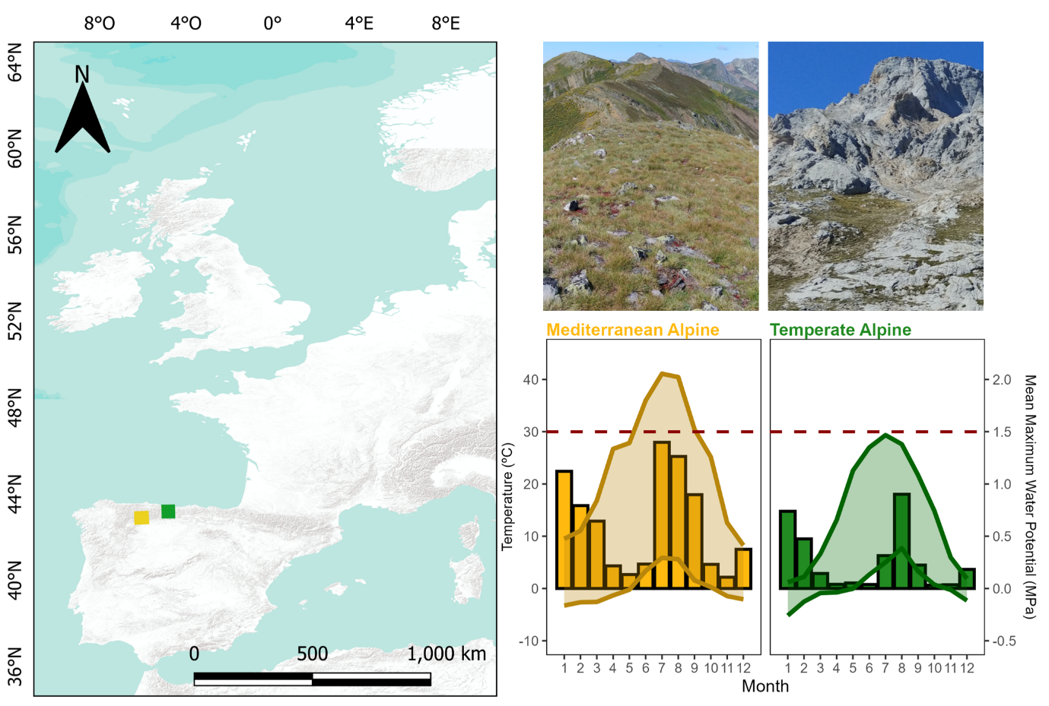
Figure 1 Study geographical and climatic description. Climatic diagram based on Microlog SP3 data from 2021 to 2025 (MicroLog SP3, EMS Brno, Czech Republic; accuracy in temperature measurements: +/- 0.3 °C from -40 °C to 60 °C; water potential measurements with Delmhorst gypsum sensors measuring range from -0.1 to -15 bars – permanent wilting point), from the eight investigated sampling sites. Lines represent monthly maximum and minimum temperatures (left y-axis); bars represent the monthly averages of the Mean Maximum Water Potential in MPa (right y-axis). Dashed horizontal red line represents the permanent wilting point (-1.5 MPa).
Table 1. Study sites specific details for both habitats. Growing season, defined as the period with daily mean temperatures above 5ºC (at 5cm deep, Körner, 2021). Snow cover calculated as the number of days in which the maximum temperatures were < 0.5 ºC and the minimum temperature was > -0.5 ºC, (Zhang et al. 2005). Temperate Alpine site soil data from to 2016 to 2024, at 5cm deep. Mediterranean Alpine site soil data from 2021 to 2024, at 5cm deep.
 | Mediterranean Alpine Habitat | Temperate Alpine Habitat
Location | Valles de Omaña y Luna Biosphere Reserve | Picos de Europa National Park
Ph range (based on 40 samples) | 3.8 - 4.8 | 6.5 - 6.8
Growing season period | mid-April to early November | mid-May to early October
Daily mean water limitation during the growing season | -0.32 to -0.52 MPa | -0.15 to -0.45 MPa
Average soil temperature | 12.2ºC | 11.4 ºC
Annual snow cover | 13 to 116 days | 57.2 to 211 days

2.2 Species selection and seed sampling
During the summers of 2021 and 2022, we periodically sampled the two study habitats to collect seeds during the release dispersal times. We collected ripe seeds or fruits (hereafter ‘seeds’ for simplicity) of all fruiting species directly from the mother plants, involving at least 20 to 50 randomly chosen individuals. Following standard protocols for sampling seeds of wild populations, the goal was to collect 400 seeds from each species to maximise intraspecific genetic diversity (ENSCONET 2009). Field permits were necessary for seed sampling in Picos de Europa National Park (granted expedition number: CO/09/203/2021). We gathered sufficient seeds from 34 species in the temperate alpine habitat and 24 species in the Mediterranean alpine habitat. Taxonomic nomenclature follows (Jiménez-Alfaro, et al., 2021). Only Thymus praecox was collected in both habitats, while the rest of the species were represented by one seed lot (n = 57). After cleaning, seed collections from 2021 were kept in room conditions (22 ºC and 35% RH) for less than three months, then moved to hermetic pots with silica gel, in a refrigerator at 5ºC and darkness, to maintain high seed viability, until the beginning of the experiment. Seed collection from 2022, were cleaning and kept in room conditions for less than three months until the beginning of the experiment in November 2022. Seed collection year was included preliminary as a random factor in the model, but results remained consistent when excluded, thus we decided not to include it in the final models.

2.3 Germination treatments
Each seed lot was sown in 16 Petri dishes (90 mm Ø) containing 25 seeds each (reduced to 20 seeds per Petri dish for two species: Avenella flexuosa and Helictochloa marginata), using 1% agar sealed with parafilm to maintain moisture. The goal was to measure germination responses both during cold stratification and afterwards to other germination cues in non-dormant seeds; thus, all seed lots (n=57 lots) were subjected to a 5-month-long cold stratification period mimicking real under-snow-like conditions (0.5ºC and darkness, Milbau et al., 2009).
Once cold stratification ended, the number of seeds that had germinated was recorded (radicle > 2 mm was used as the definition of germination), except for the Petri dishes going to the darkness treatment, which were covered with two layers of aluminium foil and immediately transferred to the growing chamber. Then, non-germinated seeds were transferred to new 90 mm Ø Petri dishes with two layers of filter paper (Filtros Anoia S.A. paper for germination assays, Ref.518G085) and 6 ml of distilled water, to subject the seeds to the control and constant temperature treatments. See Figure 2 for a schematic flowchart representing the seeds and germination steps applied, and Table 2 for detailed treatment conditions descriptions and their ecological significance. Previous research (C. Espinosa del Alba, Fernández-Pascual, and Jiménez-Alfaro 2024) has shown that the study species responds to two optimal germination temperatures. Consequently, we divided the species into these temperature regimes, programmed in four different growing chambers: some species went to a colder regime (15 – 5ºC alternating and 10ºC constant) and the other species to a warmer regime (22/12ºC alternating and 17ºC constant) (specific details available in GitHub, 2025). Optimal germination temperatures were included in preliminary models and had no effect on germination responses to the specific treatments, and we removed that factor from analysis.
For the water limitation treatment, instead of distilled water, we added 6 ml of Polyethene glycol (PEG 6000) to simulate a water potential of -0.6 MPa (Megapascals). PEG is an inert water-binding polymer that creates a negative osmotic pressure, making it more difficult for seeds to absorb water. We chose a negative osmotic potential of -0.6 MPa based on reported water-limitation “thresholds” from other alpine areas (Orsenigo et al. 2015; Tudela-Isanta et al. 2018; Clara Espinosa del Alba et al. 2025) and slightly above the mean water osmotic potential values registered in the area during the growing season (own data). As PEG solutions depend on experimental temperatures, two solutions were prepared according to (Michel and Kaufmann 1973) and (Villela, Doni Filho, and Sequeira 1991) to reach desired osmotic potentials at the mean temperatures in the two temperature regimes. Germination treatments were programmed in three Aralab growing chambers (Aralab climatic chamber Fitoclima S600 PL, equipped with 4 LED modules 11w 350mA) configured using Fitolog 9000 software (version 9308, Aralab Pharmaceutical Stability software) and one KBW growing chamber (KBW 400, Binder, Tuttlingen, Germany, specifically for the warm constant temperatures). We scored germination weekly for 6 weeks, removing germinated seeds from the Petri dishes (radicle > 2 mm long). To calculate darkness germination, we subtracted the mean germination from the final germination during cold stratification (measured in 12 petri dishes of each specific species). At the end of the experiment, we cut open non-germinated seeds under a binocular stereoscope to visually assess if they were empty, infected, or normal. We considered seeds with white and firm embryos viable and removed empty or infected seeds from germination calculations (Baskin and Baskin 2014). The final dataset (Appendix S2) consisted of the raw scoring data for 56 species (57 seed lots) representing 21 plant families. A total of 18,694 viable seeds were used in the experiment. For further analysis, we removed seven species with zero germination across all treatments, assuming that we could not break dormancy or that the seed quality during collection was not optimal.
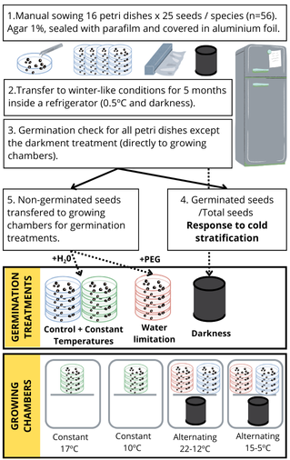
Figure 2 Schematic flowchart representing the seeds and germination steps applied in the study
Table 2. Description of germination experiments and their ecological significance
Treatment | Description | Ecological significance
Control | Alternating temperatures, 12h photoperiod and water available. | Mimic environment with theoretical optimal conditions for alpine species seed germination. Alternating temperatures, light and water available indicate safer germination microsites (Andrea Mondoni et al. 2012; Körner 2021).
Darkness | Alternating temperatures, constant darkness and water available. | Mimic the environment of seeds buried deeper in the soil, where especially small seeds (Bond, Honig, and Maze 1999) might find problems reaching the soil surface, thus germination should be avoided (Saatkamp et al. 2011).
Constant temperatures | Constant temperatures, 12h light and water available. | Mimic the environment of seeds buried deeper in the soil, where there is a small temperature variation, but higher moisture than on the surface.
Water limitation | Alternating temperatures, 12h light and PEG solution to simulate -0.6 MPa. | Mimic environment of seeds experiencing intermediate water limitation or drought, more likely if they are buried close to the surface or on it.

2.4 Statistical analysis
All analyses and figures were done with R statistical software (Team and R Core Team 2024) and graphs using ggplot2 (Wickham 2016) and patchwork (Pedersen 2023).
We analysed the germination data by fitting Markov Chain Monte Carlo generalized linear mixed models (MCMCglmm) with Bayesian estimation and a multinomial2 family using the R package MCMCGLMM (J. D. Hadfield 2010). For all models, phylogeny was included as a random factor using a reconstructed tree for the 57 species created with the V.PHYLOMAKER R package (Jin and Qian 2019) using phylosignal and phylobase R packages (Keck et al. 2016). We used weakly informative priors, with parameter-expanded priors for the random effects. Each model was run for 1,000,000 iterations, with an initial burn of 100,000 and a thinning interval of 100. From the resulting posterior distributions, we calculated mean parameter estimates and 95% credible intervals (CI). To assess the significance of the models, we use the posterior mean from posterior probabilities and the credible intervals (CI). The posterior mean is an analogue of model effect sizes, and when the CI values do not overlap with 0, there is a significant effect of the explanatory variable.
For our first question, we analysed the germination responses to cold stratification (n=51 seed lots) to test if there were differences between temperate and Mediterranean alpine habitats (germination during cold stratification ~ Habitat). For our next questions, we excluded species with more than 50% germination in cold stratification (n=10 seed lots). To test the effect of water limitation, we also excluded those species with no germination either in the control or water limitation treatments (n=7 seed lots). First, we tested the differences between control and water limitation germination (germination ~ treatment). Second, we measured the percentage of decreased germination in water limitation compared to control, e.g., if a specific species has germinated 80% in control and 20% in water limitation, the percentage germination decrease is equal to 75%:
$\left(1-\frac{20}{80}\right)*100=75$
Then, we tested the differences in the percentual germination decrease between alpine Habitats with an Exponential MCMC-GLMM (germination reduction ~ Habitats). To control germination responses to fine-scale germination drivers (n=39), we preliminarily tested whether different optimal temperatures affected germination, but were not significant and were not included in further tests. We compared germination between treatments (light control vs dark and alternating vs constant temperatures) (germination ~ treatment); and, within each germination treatment, we tested germination differences between Habitats (germination ~ habitat). Model assumptions were visually checked and fulfilled (we checked for patterns in the trace of the sampled output (time series) and density estimates of each explanatory variable (J. Hadfield 2017).

3. Results

3.1. Germination during cold stratification
During cold stratification, germination ranged from 0 (e.g., Armeria cantabrica) to 100% (e.g., Teesdalia conferta); with 10 species (out of 50) germinating >50%, three from the temperate alpine and seven from the Mediterranean alpine (Figure 2A). The top-10 species with the highest germination during cold stratification (named as “under snow germination” in Figure 2A) were removed from further analysis; the rest of the species were kept, assuming they would mostly germinate during spring and would therefore be exposed to the tested germination cues after cold stratification. There was an average of 0.24 (+/- 0.01) germination proportion in species from the Mediterranean alpine habitat, while less than 0.08 (+/- 0.006) of seeds germinated in the temperate alpine habitat. Habitat comparison detected significant differences (post. mean = -3.56, CI = [-6.22|-0.9]), with higher germination in the Mediterranean (Figure 2B). The response of cold stratification across habitats was significantly modulated by phylogeny (post. mean = 0.95, CI: [0.88|1) (see model details in Appendix S3).
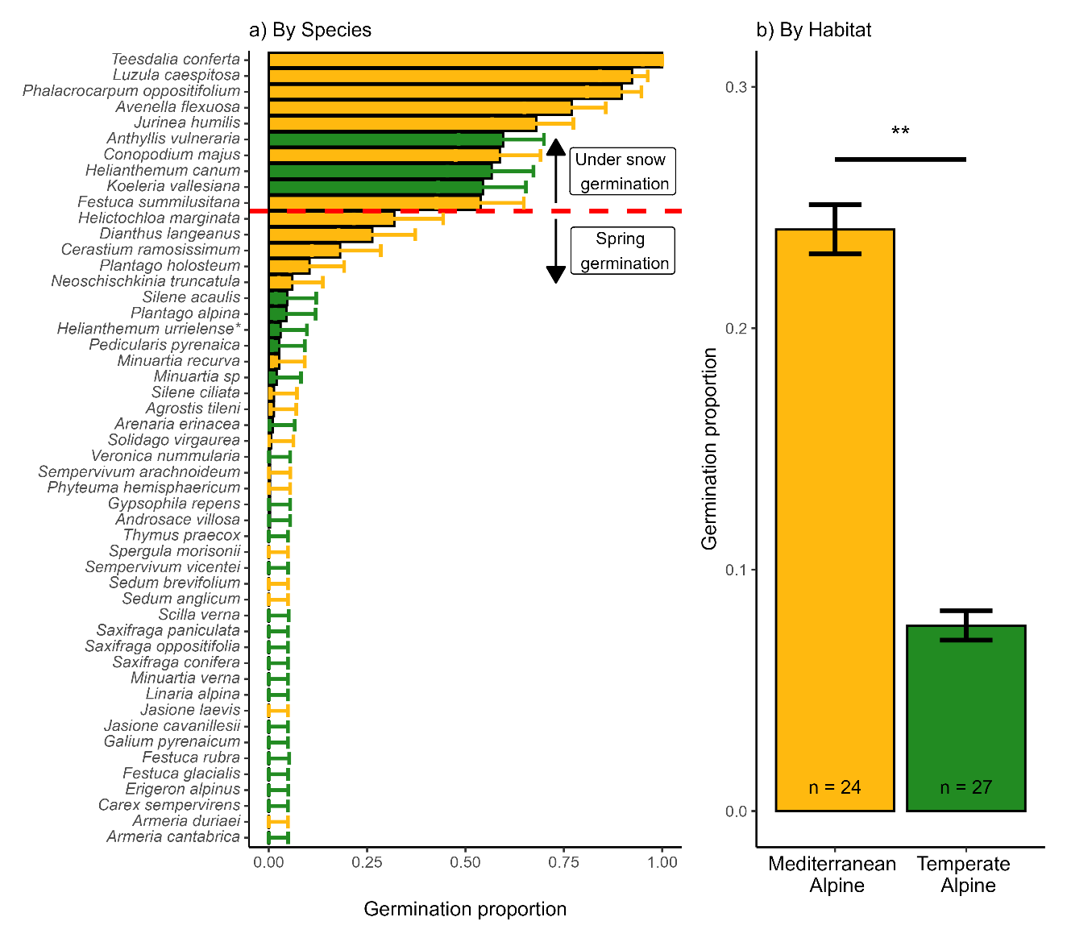
Figure 3 Germination during cold stratification. A) Accumulated germination during cold stratification across species (n = 50) coloured by Habitat. The red line marks the limit of species with >50% germination during cold stratification that will be removed from further analysis. B) Differences across habitats, n = number of species in each Habitat. Bars represent the mean germination proportion during cold stratification, and the error bar represents the binomial confidence intervals; significance derives from multinomial MCMCGLMM models, ** = p-value<0.01. Helianthemum urrielense* = Helianthemum apenninum subsp. urrielense.

3.2. Germination under water limitation
Water limitation exhibited a significantly negative effect on overall germination proportion, from 0.5 (+/- 0.02) average germination in the control to 0.16 (+/- 0.01) in water limitation (post. mean = -3.32, CI= [-3.71|-2.94]), Figure 3A. Although the mean percentual decrease was slightly higher in the temperate alpine habitat (mean germination reduction of 77.6% and 63.4% temperate alpine and Mediterranean, respectively), the differences were not significant (post. mean = -28.5, CI= [-145.3|100.8]); Figure 3B. The percentage of decreased germination ranged from 100%, i.e., no germination at all under water limitation (e.g., Sedum brevifolium) to 1%, i.e., practically no effect of water limitation (-0.6 MPa) (e.g., Plantago holosteum); see Figure 3C for species individual responses. The germination response to water limitation does not appear to be modulated by phylogeny (see model details in Appendix S3).
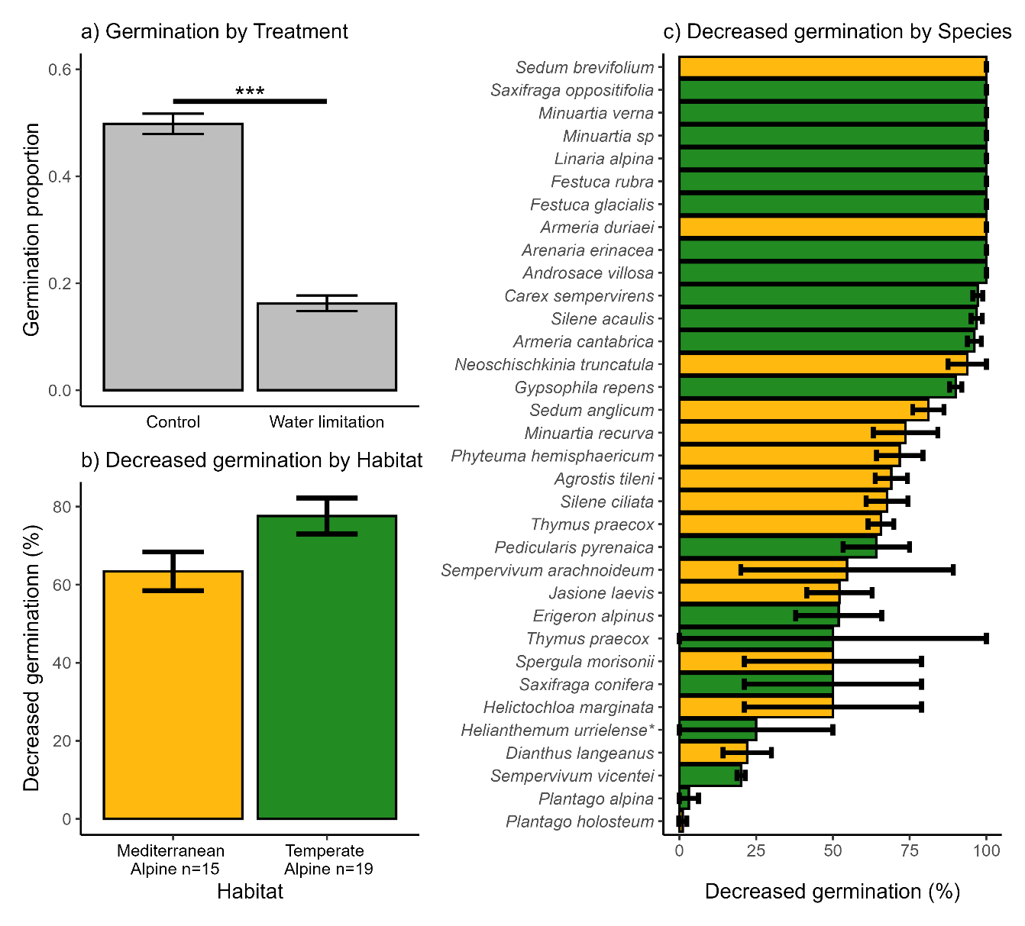
Figure 4 Germination responses under water limitation. A) Bars represent the mean germination observed per treatment, and error bars represent binomial confidence intervals. Significances from multinomial MCMC-GLMM models *** = p-value<0.001. B) Bars represent the mean germination reduction under water limitation in each Habitat, and error bars represent the Standard error of the mean. C) Decreased germination in each species, Bars represent the mean germination reduction under water limitation in each Habitat, and error bars represent the Standard error of the mean. Colour represents the Habitat of the species. Helianthemum urrielense* = Helianthemum apenninum subsp. urrielense.

3.3. Germination responses to dark and constant temperatures
The highest mean germination proportion was recorded in the constant temperature treatment (0.47 +/- 0.02), followed by control (0.42 +/- 0.02) and darkness (0.36 +/- 0.02). Germination was significantly higher in constant temperatures (post. mean = 0.42, CI= [0.1|0.72]) and significantly lower in darkness (post. mean = -0.52, CI= [-0.84|-0.21]) compared to the control (Figure 4A). When comparing both habitats, we did not observe significant differences in germination within either treatment, although the Mediterranean habitat showed slightly higher germination under all treatments; see Figure 4B (model details in Appendix S3). The differential germination response to darkness across habitats was significantly modulated by phylogeny (post. mean = 0.86, CI: [0.29|1]). Individual species germination responses to each treatment are available in Appendix S1 and Appendix S4.
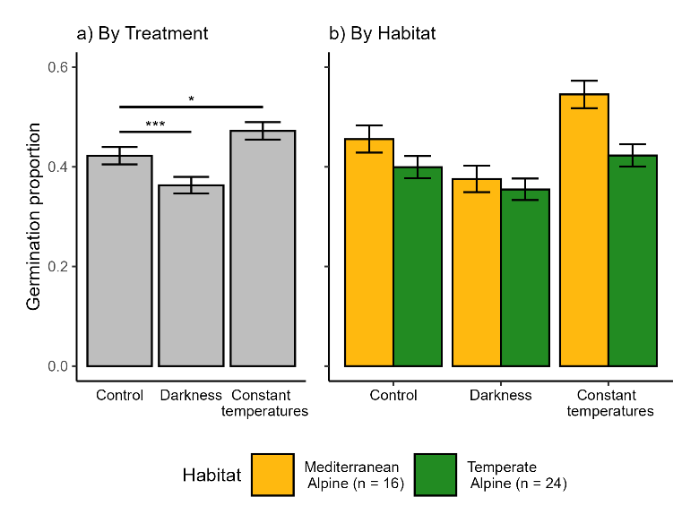
Figure 5 Germination responses to darkness and constant temperature treatments. A) Bars represent the mean germination observed per treatment, error bars represent binomial confidence intervals, significances from multinomial MCMC-GLMM models, * = p-value < 0.05 and *** = p-value < 0.005. B) Bars represent the mean germination observed per treatment in each Habitat, and error bars represent binomial confidence intervals; n represents the number of species in each alpine habitat included in this analysis

4. Discussion
In this study, we focused on germination cues related to snow cover and water availability in alpine ecosystems, comparing species from two habitats with different macroclimates, while controlling for other known germination cues (responses to darkness and constant temperatures). The main germination differences between habitats were related to their response to cold stratification. In contrast, both habitats showed similar responses to water limitation and darkness (by decreasing germination), and to constant temperatures (by enhancing germination).
As expected, we found higher germination during cold stratification in species from a Mediterranean alpine habitat. This supports the presence of lower physiological dormancy within the Mediterranean alpine species pool (Giménez-Benavides, Escudero, and Pérez-García 2005), and is consistent with the Mediterranean germination syndrome, characterised by a preferential germination in darkness and at lower temperatures (Doussi and Thanos 2002; Angelino Carta et al. 2017). These germination responses enable seeds to capitalise on early-season water availability and develop before the onset of summer drought. We note that the three species from the temperate habitat with >50% germination during stratification (Anthyllis vulneraria, Helianthemum canum and Koeleria vallesiana) are adapted to the drier and less snowy places in Picos de Europa National Park (Jiménez-Alfaro et al. 2014) thus, they are adapted to relatively more Mediterranean-like conditions. The only previous study comparing cold stratification (0 °C and darkness at 0, 3, and 5 months) between alpine habitats found higher germination during cold stratification in species from the calcareous habitat (drier) compared to those from the siliceous habitat (wetter) (Tudela-Isanta et al. 2017). Thus, there appears to be a pattern where alpine species adapted to drier conditions germinate better under cold and humid conditions. Although we interpret that these species can germinate “under snow”, the snow cover period is highly variable and relatively short in our Mediterranean habitat, meaning that the seeds of the study species do not need specific adaptations to avoid snow. In contrast, our temperate habitat has a longer regime of snow cover, so the species require strategies to avoid it (deep dormancy and warm germination), in line with the Alpine germination syndrome. Notably, among the top ten species with higher cold stratification germination, eight are generalist species that extend their distribution to subalpine grasslands. Subalpine species are known to germinate more effectively under snow (E. Fernández-Pascual et al. 2017) or at colder temperatures (Baskin and Baskin 2014); therefore, our results align with those previously reported. Interestingly, some of our studied species (Luzula caespitosa (Juncaceae), Teesdalia conferta (Brassicaceae) or Conopodium majus (Apiaceae)) seem to be restricted to germinating only under snow or at low temperatures, corroborating previous research (E. Fernández-Pascual et al. 2017; C. Espinosa del Alba, Fernández-Pascual, and Jiménez-Alfaro 2024), either due to dormancy restrictions or underdeveloped embryos (Blandino et al. 2018).
Corroborating previous literature reports from alpine habitats (Orsenigo et al. 2015; Gya et al. 2023; Clara Espinosa del Alba et al. 2025), water limitation negatively affected germination in most study species, regardless of the habitat type. Low moisture availability leads to partial or complete inhibition of physiological processes, which can hinder seeds from germinating (Baskin and Baskin 2014). Against our initial expectation, we found no significant reduction in germination in the alpine habitat. Nevertheless, it is interesting to note that species from the Mediterranean habitat seem to exhibit intermediate germination responses to water limitation (mostly between 25% and 75% decreases). In comparison, most species from our temperate habitat showed a germination reduction higher than 90%, and only five species showed a reduction of less than 50%. These results suggest that in the temperate habitat species pool, we found two opposing responses to drought (at -0.6 MPa): either very sensitive (most species) or non-sensitive species. These results suggest that alpine communities from the temperate habitat are likely to face higher detrimental effects from future drier conditions, since many of the occurring species will reduce their germinability. Additionally, more strict alpine species, such as Minuartia verna, Festuca glacialis, Armeria duriaei, or Carex sempervirens, generally showed higher decreased germination under water limitation than other subalpine or generalist species (e.g., Plantago holosteum or Helictochloa marginata). When these species migrate from lower-elevation habitats, they usually occur in sites with early snowmelt and are subjected to higher summer drought. Our findings further indicate that, besides general patterns observed within the study habitats, the response of different species within the local species pool may vary according to individual species' niches.
The significantly lower germination we observed in darkness conditions is in concordance with the general alpine germination syndrome (Shimono and Kudo 2005; A. Mondoni et al. 2009; Eduardo Fernández-Pascual et al. 2021) and Mediterranean mountain specialist germination (Giménez-Benavides, Escudero, and Pérez-García 2005; Picciau et al. 2019; Cruz-Tejada et al. 2024). Increased burial depth may be detrimental for small seeds with lower energy stored to survive the first few centimetres of soil (Saatkamp et al. 2011), which might be the case for most species in our study. Surprisingly, both systems exhibited a trend of higher germination under constant temperatures, which is opposite to the general reported patterns for alpine floras (Eduardo Fernández-Pascual et al. 2021). While diurnally alternating temperatures can promote radicle growth by reducing the ratio of abscisic acid to gibberellin (Huarte and Benech-Arnold 2010), thereby relieving dormancy and stimulating germination (Fenner and Thompson 2005; Eduardo Fernández-Pascual, Seal, and Pritchard 2015); the results we observed might be because our seeds in the constant treatment experienced a longer time under “warmer” temperatures than those in the alternating temperature treatments, and therefore accumulated more heat units towards germination (Picciau et al. 2019).
Overall, the results presented in this study suggest that alpine germination of many species will be heavily impacted by changes in water availability derived from reduced snow cover and increasing water limitation under current climate warming (Morán-Tejeda et al. 2013). The responses we observed indirectly favour less dormant species (Verdú et al. 2005; Andrea Mondoni et al. 2015) or species with no stratification requirement (Sommerville, Martyn, and Offord 2013). Some germination responses will be partly alleviated by the plasticity of physiological seed dormancy in response to the seed maturation temperature (Eduardo Fernández-Pascual et al. 2013; A. Carta et al. 2015; Eduardo Fernández-Pascual, Mattana, and Pritchard 2019) or via maternal effects that facilitate acclimatisation to changing environments. Nevertheless, due to the large interspecific variation of germination responses, reflecting species-specific requirements (Orsenigo et al. 2015; Walder and Erschbamer 2015; E. Fernández-Pascual et al. 2017), future alpine communities might shift towards a more drought-resistant community. Thus, variations in snow cover can alter plant community structure by influencing seed germination patterns (Anniwaer et al. 2020) and may also have a more substantial impact on seed germination than passive warming (Drescher 2014). Expanding our knowledge about the specific effects of shortened snow cover protection (Briceño, Hoyle, and Nicotra 2015; Anniwaer et al. 2020) and increased water limitation on alpine species germination is needed to forecast future potential impacts of climate change, p.eg. experiencing reduced snow (Morán-Tejeda et al. 2013) or increased drought (Beniston et al. 2007).
Conclusion
This study demonstrates that species from Mediterranean alpine habitats diverge from the typical Alpine germination syndrome primarily in their response to cold and wet winter conditions – likely as an adaptation to reduced snow cover – which aligns with the Mediterranean germination syndrome. Since the Alpine germination syndrome has been mainly described for temperate regions (Eduardo Fernández-Pascual et al. 2021), our results open the door to other germination strategies linked to multiple climatic variations occurring in alpine habitats worldwide (Testolin, Attorre, and Jiménez-Alfaro 2020). Species-specific germination responses suggest that, in a warmer and drier alpine scenario, winner species will be those with lower requirements for cold stratification and water availability for germination, facilitating a directional shift in alpine community composition. Our results also support the idea that seed germination traits, especially the responses to snow and water availability, might play an essential role in understanding the regeneration ecology of alpine plant communities under climate change (Briceño, Hoyle, and Nicotra 2015; Andrea Mondoni et al. 2022). Nevertheless, these results are based on laboratory experiments, and how the findings transfer to natural communities is unclear; therefore, increasing field experimentation in seed regeneration (Milbau et al. 2009) is needed to predict responses in the field more precisely.

5. References
Anniwaer, Anlifeire, Yangui Su, Xiaobing Zhou, and Yuanming Zhang. 2020. “Impacts of Snow on Seed Germination Are Independent of Seed Traits and Plant Ecological Characteristics in a Temperate Desert of Central Asia.” Journal of Arid Land 12 (5): 775–90. https://doi.org/10.1007/s40333-020-0059-9.
Baskin, Carol C., and Jerry M. Baskin. 2014. Seeds. Ecology, Biogeography and Evolution of Dormancy and Germination. Seeds. 2nd Editio. San Diego, CA, USA: Academic Press. https://doi.org/10.1016/B978-0-12-416677-6.00001-9.
Beniston, Martin, David B. Stephenson, Ole B. Christensen, Christopher A.T. Ferro, Christoph Frei, Stéphane Goyette, Kirsten Halsnaes, et al. 2007. “Future Extreme Events in European Climate: An Exploration of Regional Climate Model Projections.” Climatic Change 81: 71–95. https://doi.org/10.1007/s10584-006-9226-z.
Blandino, C., E. Fernández-Pascual, M. Marin, A. Vernet, and H. W. Pritchard. 2018. “Seed Ecology of the Geophyte Conopodium Majus (Apiaceae), Indicator Species of Ancient Woodland Understories and Oligotrophic Meadows.” Plant Biology 21 (3): 487–97. https://doi.org/10.1111/plb.12872.
Bond, W. J., M. Honig, and K. E. Maze. 1999. “Seed Size and Seedling Emergence: An Allometric Relationship and Some Ecological Implications.” Oecologia 120 (1): 132–36. https://doi.org/10.1007/s004420050841.
Briceño, Verónica F., Gemma L. Hoyle, and Adrienne B. Nicotra. 2015. “Seeds at Risk: How Will a Changing Alpine Climate Affect Regeneration from Seeds in Alpine Areas?” Alpine Botany 125 (2): 59–68. https://doi.org/10.1007/s00035-015-0155-1.
Carta, A., R. Probert, G. Puglia, L. Peruzzi, and G. Bedini. 2015. “Local Climate Explains Degree of Seed Dormancy in Hypericum Elodes L. (Hypericaceae).” Plant Biology 18 (Suppl. 1): 76–82. https://doi.org/10.1111/plb.12310.
Carta, Angelino, Evangelia Skourti, E Mattana, Filip Vandelook, and Costas A Thanos. 2017. “Photoinhibition of Seed Germination : Occurrence , Ecology and Phylogeny Photoinhibition of Seed Germination : Occurrence , Ecology and Phylogeny.” Seed Science Research 27: 131–53. https://doi.org/10.1017/S0960258517000137.
Cavieres, Lohengrin A., and Mary T.K. Arroyo. 2000. “Seed Germination Response to Cold Stratification Period and Thermal Regime in Phacelia Secunda (Hydrophyllaceae): Altitudinal Variation in the Mediterranean Andes of Central Chile.” Plant Ecology 149 (1): 1–8. https://doi.org/10.1023/A:1009802806674.
Cavieres, Lohengrin A., and Angela Sierra-Almeida. 2018. “Assessing the Importance of Cold-Stratification for Seed Germination in Alpine Plant Species of the High-Andes of Central Chile.” Perspectives in Plant Ecology, Evolution and Systematics 30: 125–31. https://doi.org/10.1016/j.ppees.2017.09.005.
Cruz-Tejada, Diana Maria, Efisio Mattana, Sergey Rosbakh, Eduardo Fernández-Pascual, and Angelino Carta. 2024. “Macroclimatic Convergence and Habitat Specialisation Shape the Mediterranean Seed Germination Syndrome.” Ecology and Evolution 14 (11): 1–8. https://doi.org/10.1002/ece3.70527.
Decker, K.L.M., D. Wang, C. Waite, and T. Scherbatskoy. 2003. “Snow Removal and Ambient Air Temperature Effects of Forest Soil Temperatures in Northern Vermont.” Soil Science Society of America Journal 67 (5): 1629–1629. https://doi.org/10.2136/sssaj2003.1629.
Donohue, Kathleen, Rafael Rubio De Casas, Liana Burghardt, Katherine Kovach, and Charles G. Willis. 2010. “Germination, Postgermination Adaptation, and Species Ecological Ranges.” Annual Review of Ecology, Evolution, and Systematics 41: 293–319. https://doi.org/10.1146/annurev-ecolsys-102209-144715.
Doussi, Maria A., and Costas A. Thanos. 2002. “Ecophysiology of Seed Germination in Mediterranean Geophytes. 1. Muscari Spp.” Seed Science Research 12 (3): 193–201. https://doi.org/10.1079/ssr2002111.
Drescher, Michael. 2014. “Snow Cover Manipulations and Passive Warming Affect Post-Winter Seed Germination: A Case Study of Three Cold-Temperate Tree Species.” Climate Research 60 (3): 175–86. https://doi.org/10.3354/cr01237.
ENSCONET. 2009. ENSCONET Seed Collecting Manual for Wild Species. Edited by Kew (UK) Royal Botanic Gardens and Universidad Politécnica de Madrid (Spain).
Espinosa del Alba, C., E. Fernández-Pascual, and B. Jiménez-Alfaro. 2024. “Microclimatic Variation Regulates Seed Germination Phenology in Alpine Plant Communities.” Journal of Ecology, no. November: 1–14. https://doi.org/10.1111/1365-2745.14461.
Espinosa del Alba, Clara, Diana Maria Cruz-Tejada, Borja Jiménez-Alfaro, and Eduardo Fernández-Pascual. 2025. “Functional Intraspecific Variation in the Base Water Potential for Seed Germination along Soil Microclimatic Gradients.” Functional Ecology 39 (3): 897–911. https://doi.org/10.1111/1365-2435.14754.
Fenner, M., and K. Thompson. 2005. “The Ecology of Seeds.” In The Ecology of Seeds, edited by M. Fenner and K. Thompson, 110–35. Cambridge, UK: Cambridge: Cambridge Uniersity Press.
Fernández-Pascual, E., B. Jiménez-Alfaro, A Bueno, and Bueno. 2017. “Comparative Seed Germination Traits in Alpine and Subalpine Grasslands: Higher Elevations Are Associated with Warmer Germination Temperatures.” Plant Biology 19 (1): 32–40. https://doi.org/10.1111/plb.12472.
Fernández-Pascual, Eduardo, Angelino Carta, Andrea Mondoni, Lohengrin A. Cavieres, Sergey Rosbakh, Susanna Venn, Annisa Satyanti, et al. 2021. “The Seed Germination Spectrum of Alpine Plants: A Global Meta-Analysis.” New Phytologist 229 (6): 3573–86. https://doi.org/10.1111/nph.17086.
Fernández-Pascual, Eduardo, Borja Jiménez-Alfaro, Juli Caujapé-Castells, Ruth Jaén-Molina, and Tomás Emilio Díaz. 2013. “A Local Dormancy Cline Is Related to the Seed Maturation Environment, Population Genetic Composition and Climate.” Annals of Botany 112 (5): 937–45. https://doi.org/10.1093/aob/mct154.
Fernández-Pascual, Eduardo, Efisio Mattana, and Hugh W. Pritchard. 2019. “Seeds of Future Past: Climate Change and the Thermal Memory of Plant Reproductive Traits.” Biological Reviews 94 (2): 439–56. https://doi.org/10.1111/brv.12461.
Fernández-Pascual, Eduardo, Charlotte E. Seal, and Hugh W. Pritchard. 2015. “Simulating the Germination Response to Diurnally Alternating Temperatures under Climate Change Scenarios: Comparative Studies on Carex Diandra Seeds.” Annals of Botany 115 (2): 201–9. https://doi.org/10.1093/aob/mcu234.
García-Gutiérrez, Teresa, Borja Jiménez-Alfaro, Eduardo Fernández-Pascual, and Jonas V. Müller. 2018. “Functional Diversity and Ecological Requirements of Alpine Vegetation Types in a Biogeographical Transition Zone.” Phytocoenologia 48 (1): 77–89. https://doi.org/10.1127/phyto/2017/0224.
Giménez-Benavides, L., A. Escudero, and F. Pérez-García. 2005. “Seed Germination of High Mountain Mediterranean Species: Altitudinal, Interpopulation and Interannual Variability.” Ecological Research 20 (4): 433–44. https://doi.org/10.1007/s11284-005-0059-4.
Gya, Ragnhild, Sonya Rita Geange, Joshua Scott Lynn, Joachim Paul Töpper, Øystein Wallevik, Camilla Zernichow, and Vigdis Vandvik. 2023. “A Test of Local Adaptation to Drought in Germination and Seedling Traits in Populations of Two Alpine Forbs across a 2000 Mm/Year Precipitation Gradient.” Ecology and Evolution 13 (2): 1–19. https://doi.org/10.1002/ece3.9772.
Hadfield, Jarrod. 2017. MCMCglmm Course Notes.
Hadfield, Jarrod D. 2010. “MCMCglmm: MCMC Methods for Multi-Response GLMMs in R.” Journal of Statistical Software 33 (2): 1–22. http://www.jstatsoft.org/.
Huarte, H. Roberto, and Roberto L. Benech-Arnold. 2010. “Hormonal Nature of Seed Responses to Fluctuating Temperatures in Cynara Cardunculus (L.).” Seed Science Research 20 (1): 39–45. https://doi.org/10.1017/S0960258509990249.
Jiménez-Alfaro, Borja, Sylvain Abdulhak, Fabio Attorre, Ariel Bergamini, Maria Laura Carranza, Alessandro Chiarucci, and Manuela Winkler. 2021. “Post-Glacial Determinants of Regional Species Pools in Alpine Grasslands.” Global Ecology Biogeography 30: 1101–15. https://doi.org/https://doi.org/10.1111/geb.13274.
Jiménez-Alfaro, Borja, José Ignacio Alonso Felpete, Álvaro Bueno Sánchez, and José Antonio Fernández Prieto. 2014. “Alpine Plant Communities in the Picos de Europa Calcareous Massif (Northern Spain).” Lazaroa 35 (0). https://doi.org/10.5209/rev_laza.2013.v34.n1.43646.
Jiménez-Alfaro, Borja, Luis Carlón, Eduardo Fernández-Pascual, Carmen Acedo, Estrella Alfaro-Saiz, Raquel Alonso Redondo, Eduardo Cires, et al. 2021. “Checklist of the Vascular Plants of the Cantabrian Mountains.” Mediterranean Botany 42: 1–60. https://doi.org/10.5209/MBOT.74570.
Jin, Yi, and Hong Qian. 2019. “V.PhyloMaker: An R Package That Can Generate Very Large Phylogenies for Vascular Plants.” Ecography 42 (8): 1353–59. https://doi.org/10.1111/ecog.04434.
Keck, Francois, Frederic Rimet, Agnes Bouchez, and Alain Franc. 2016. “Phylosignal: An R Package to Measure, Test, and Explore the Phylogenetic Signal.” Ecology and Evolution 6 (9): 2774–80. https://doi.org/10.1002/ece3.2051.
Körner, Christian. 2021. Alpine Plant Life. Edited by Springer Nature Switzerland AG 2021. 3rd ed. Springer Cham. https://doi.org/10.1007/978-3-030-59538-8.
Margreiter, Vera, Konrad Pagitz, Christian Berg, Patrick Schwager, and Brigitta Erschbamer. 2020. “Pros and Cons of Using a Standard Protocol to Test Germination of Alpine Species.” Plant Ecology 221 (11): 1045–67. https://doi.org/10.1007/s11258-020-01061-w.
Michel, Burlyn E, and Merrill R Kaufmann. 1973. “The Osmotic Potential of Polyethylene Glycol 60001,” 914–16.
Milbau, Ann, Bente Jessen Graae, Anna Shevtsova, and Ivan Nijs. 2009. “Effects of a Warmer Climate on Seed Germination in the Subarctic.” Annals of Botany 104 (2): 287–96. https://doi.org/10.1093/aob/mcp117.
Mondoni, A., M. I. Daws, J. Belotti, and G. Rossi. 2009. “Germination Requirements of the Alpine Endemic Silene Elisabethae Jan: Effects of Cold Stratification, Light and GA3.” Seed Science and Technology 37 (1): 79–87. https://doi.org/10.15258/sst.2009.37.1.10.
Mondoni, Andrea, B. Jiménez-Alfaro, Lohengrin A. Cavieres, Borja Jiménez‐Alfaro, and Lohengrin A. Cavieres. 2022. “Effect of Climate Change on Plant Regeneration from Seeds in the Arctic and Alpine Biome.” In Plant Regeneration from Seeds: AGlobal Warming Perspective, edited by Carol C. Baskin and Jerry M. Baskin, 1st ed., 3–18. London, UK: Academic Press.
Mondoni, Andrea, Simone Pedrini, Giulietta Bernareggi, Graziano Rossi, Thomas Abeli, Robin J. Probert, Michele Ghitti, Costantino Bonomi, and Simone Orsenigo. 2015. “Climate Warming Could Increase Recruitment Success in Glacier Foreland Plants.” Annals of Botany 116 (6): 907–16. https://doi.org/10.1093/aob/mcv101.
Mondoni, Andrea, Graziano Rossi, Simone Orsenigo, and Robin J. Probert. 2012. “Climate Warming Could Shift the Timing of Seed Germination in Alpine Plants.” Annals of Botany 110 (1): 155–64. https://doi.org/10.1093/aob/mcs097.
Morán-Tejeda, Enrique, Sixto Herrera, J. Ignacio López-Moreno, Jesús Revuelto, Anthony Lehmann, and Martin Beniston. 2013. “Evolution and Frequency (1970-2007) of Combined Temperature-Precipitation Modes in the Spanish Mountains and Sensitivity of Snow Cover.” Regional Environmental Change 13 (4): 873–85. https://doi.org/10.1007/s10113-012-0380-8.
Nogués Bravo, David, Miguel B. Araújo, Teodoro Lasanta, and Juan Ignacio López Moreno. 2008. “Climate Change in Mediterranean Mountains during the 21st Century.” Ambio 37 (4): 280–85. https://www.jstor.org/stable/25547898.
Notarnicola, Rocco F., Adrienne B. Nicotra, Loeske E.B. Kruuk, and Pieter A. Arnold. 2022. “Effects of Warming Temperatures on Germination Responses and Trade-Offs between Seed Traits in an Alpine Plant.” Journal of Ecology 111 (1): 62–76. https://doi.org/10.1111/1365-2745.14014.
Orsenigo, Simone, Thomas Abeli, Graziano Rossi, Paolo Bonasoni, Cristian Pasquaretta, Maurizia Gandini, and Andrea Mondoni. 2015. “Effects of Autumn and Spring Heat Waves on Seed Germination of High Mountain Plants.” PLoS ONE 10 (7): 1–17. https://doi.org/10.1371/journal.pone.0133626.
Pedersen, Thomas Lin. 2023. “Patchwork: The Composer of Plots.” https://cran.r-project.org/package=patchwork.
Picciau, Rosangela, Hugh W. Pritchard, Efisio Mattana, and Gianluigi Bacchetta. 2019. “Thermal Thresholds for Seed Germination in Mediterranean Species Are Higher in Mountain Compared with Lowland Areas.” Seed Science Research 29 (1): 44–54. https://doi.org/10.1017/S0960258518000399.
Saatkamp, Arne, Laurence Affre, Thierry Dutoit, and Peter Poschlod. 2011. “Germination Traits Explain Soil Seed Persistence across Species: The Case of Mediterranean Annual Plants in Cereal Fields.” Annals of Botany 107 (3): 415–26. https://doi.org/10.1093/aob/mcq255.
Schwienbacher, Erich, Jose Antonio Navarro-Cano, Gilbert Neuner, and Brigitta Erschbamer. 2011. “Seed Dormancy in Alpine Species.” Flora: Morphology, Distribution, Functional Ecology of Plants 206 (10): 845–56. https://doi.org/10.1016/j.flora.2011.05.001.
Shimono, Yoshiko, and Gaku Kudo. 2005. “Comparisons of Germination Traits of Alpine Plants between Fellfield and Snowbed Habitats.” Ecological Research 20 (2): 189–97. https://doi.org/10.1007/s11284-004-0031-8.
Sillmann, J., V. V. Kharin, F. W. Zwiers, X. Zhang, and D. Bronaugh. 2013. “Climate Extremes Indices in the CMIP5 Multimodel Ensemble: Part 2. Future Climate Projections.” Journal of Geophysical Research Atmospheres 118 (6): 2473–93. https://doi.org/10.1002/jgrd.50188.
Sommerville, Karen D., Amelia J. Martyn, and Catherine A. Offord. 2013. “Can Seed Characteristics or Species Distribution Be Used to Predict the Stratification Requirements of Herbs in the Australian Alps?” Botanical Journal of the Linnean Society 172 (2): 187–204. https://doi.org/10.1111/boj.12021.
Team, R Core, and R Core Team. 2024. “R: A Language and Environment for Statistical Computing.” Vienna: R Foundation for Statistical computing. https://www.r-project.org/.
Testolin, Riccardo, Fabio Attorre, and Borja Jiménez-Alfaro. 2020. “Global Distribution and Bioclimatic Characterization of Alpine Biomes.” Ecography 43 (6): 779–88. https://doi.org/10.1111/ecog.05012.
Tudela-Isanta, Maria, Eduardo Fernández-Pascual, Malaka Wijayasinghe, Simone Orsenigo, Graziano Rossi, Hugh W. Pritchard, and Andrea Mondoni. 2017. “Habitat-Related Seed Germination Traits in Alpine Habitats.” Ecology and Evolution 8 (1): 150–61. https://doi.org/10.1002/ece3.3539.
Tudela-Isanta, Maria, Emma Ladouceur, Malaka Wijayasinghe, Hugh W. Pritchard, and Andrea Mondoni. 2018. “The Seed Germination Niche Limits the Distribution of Some Plant Species in Calcareous or Siliceous Alpine Bedrocks.” Alpine Botany 128 (1): 83–95. https://doi.org/10.1007/s00035-018-0199-0.
Vázquez-Ramirez, Jerónimo, and Susanna E. Venn. 2021. “Seeds and Seedlings in a Changing World : A Systematic Review and Meta-Analysis from High Altitude and High Latitude Ecosystems.” Plants 10 (768). https://doi.org/10.3390/plants10040768.
Verdú, A, Anna Traveset, M Verdú, and Anna Traveset. 2005. “EARLY EMERGENCE ENHANCES PLANT FITNESS: A PHYLOGENETICALLY CONTROLLED META-ANALYSIS.” Ecology 86 (6): 1385–94. https://doi.org/10.1890/04-1647.
Villela, Francisco Amaral, Luiz Doni Filho, and Eliseo Lecrerc Sequeira. 1991. “Tabela de Potencial Osmótico Em Função Da Concentração de Polietileno Glicol 6.000 e Da Temperatura.” Pesquisa Agropecuária Brasileira 26 (11/12): 1957–68.
Walck, Jeffrey L., Siti N. Hidayati, Kingsley W. Dixon, Ken Thompson, and Peter Poschlod. 2011. “Climate Change and Plant Regeneration from Seed.” Global Change Biology 17 (6): 2145–61. https://doi.org/10.1111/j.1365-2486.2010.02368.x.
Walder, Theresa, and Brigitta Erschbamer. 2015. “Temperature and Drought Drive Differences in Germination Responses between Congeneric Species along Altitudinal Gradients.” Plant Ecology 216 (9): 1297–1309. https://doi.org/10.1007/s11258-015-0509-1.
Wickham, Hadley. 2016. “Ggplot2: Elegant Graphics for Data Analysis.” New York: Springer-Verlag.
Zhang, Yu, Wenjun Chen, Sharon L. Smith, Daniel W. Riseborough, and Josef Cihlar. 2005. “Soil Temperature in Canada during the Twentieth Century: Complex Responses to Atmospheric Climate Change.” Journal of Geophysical Research D: Atmospheres 110 (3): 1–15. https://doi.org/10.1029/2004JD004910.

